Gavin Sit

215 043 870

**Part 1**

Registry Manipulation

Code:

Addi x1, x0, 5 // adds 5 + x0 and store them in x1 (x0 always is 0)

addi x2, x0, 7 // adds 7 +x0 and stores it in x2 (x2 is 7)

add x3, x1, x2

Before compiling:

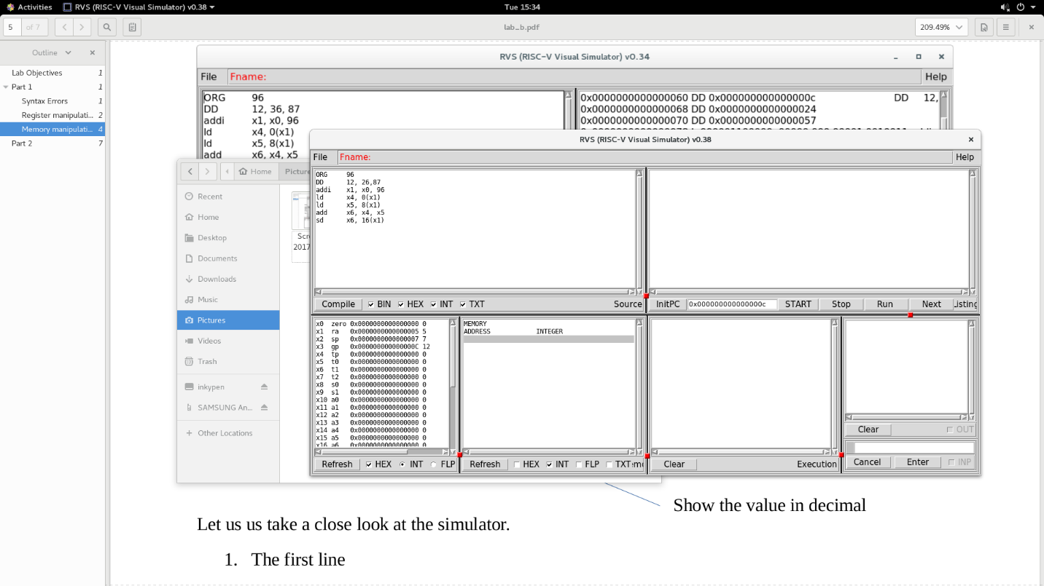

After compiling:

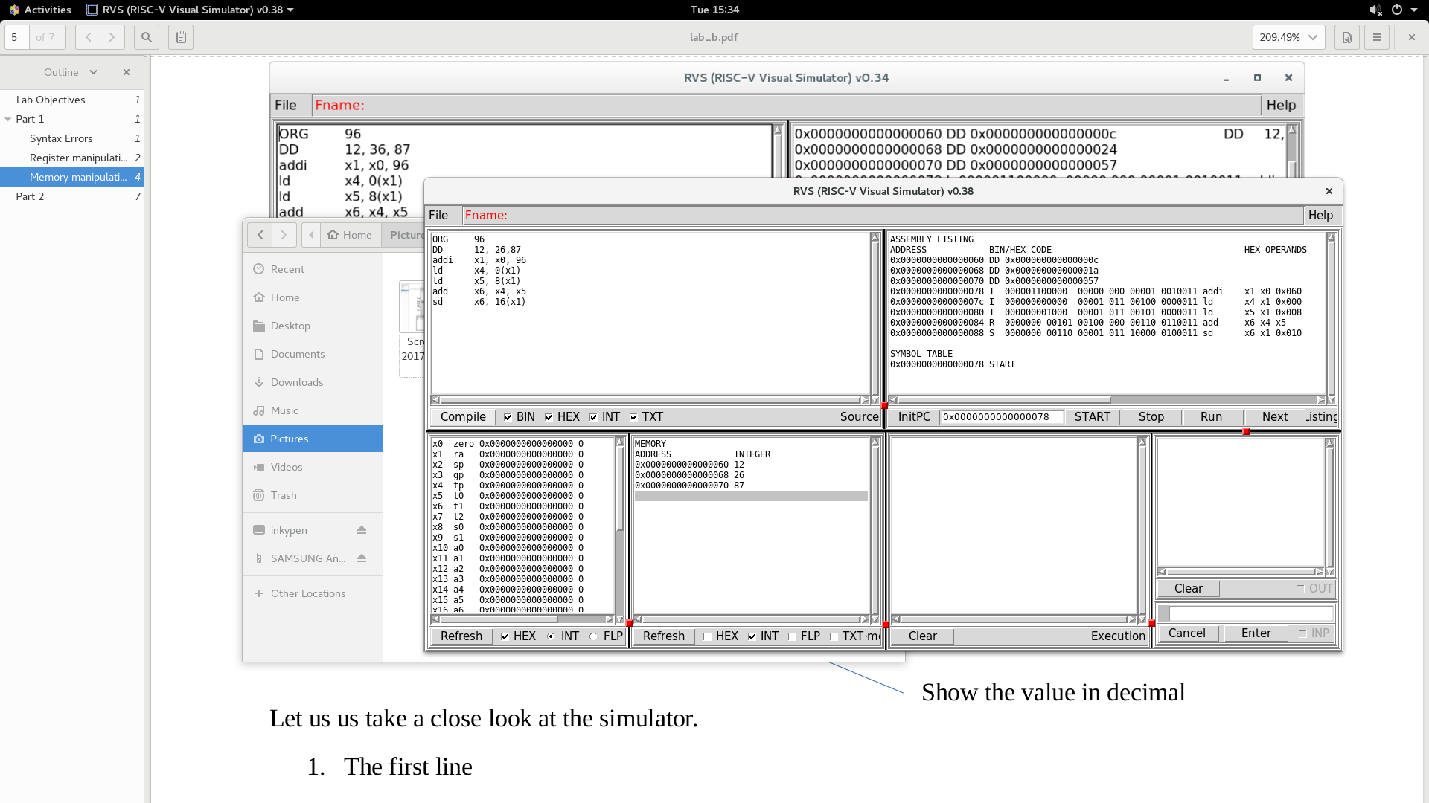

After running:



Memory Manipulation

Code:

ORG 96

DD 12, 36, 87

addi x1, x0, 96

ld x4, 0(x1)

ld x5, 8(x1)

add x6, x4, x5

sd x6, 16(x1)

Before compiling: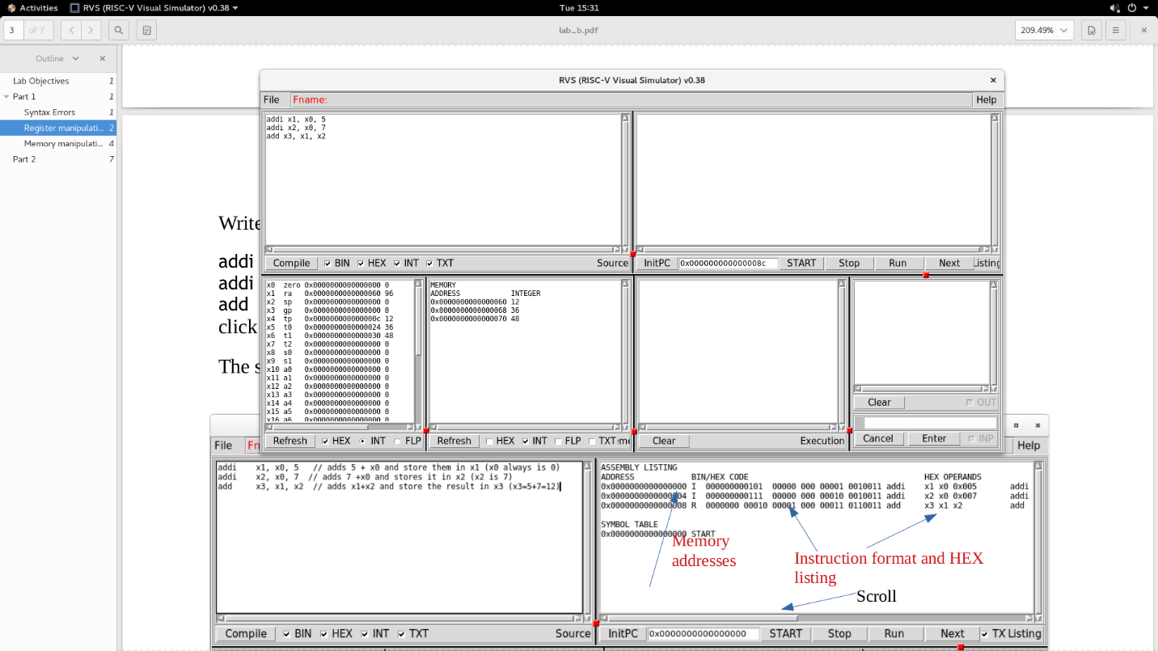

After Compiling:

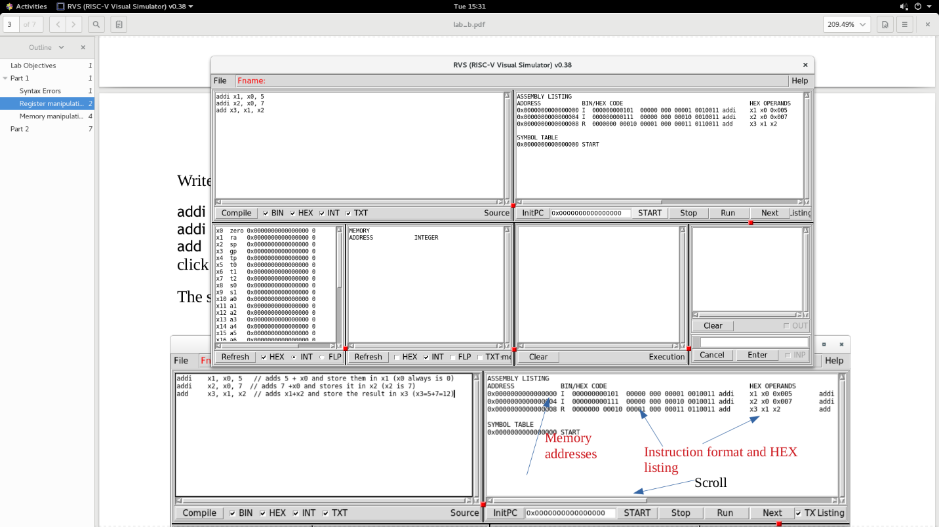

After running:

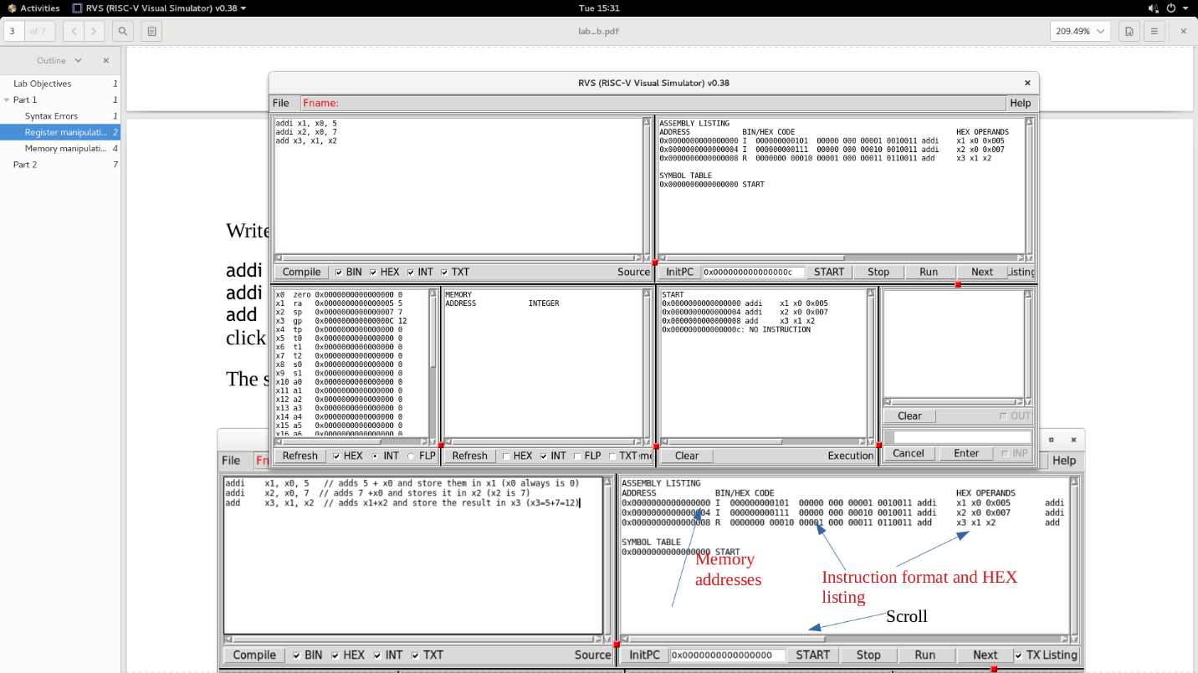

**Part 2**

Code:

ORG 96

DD 12, 3, 11

addi x1, x0, 96

ld x2, 0(x1)

ld x3, 8(x1)

ld x4, 16(x1)

addi x5, x4, 15

sub x6, x5, x3

add x7, x6, x2

addi x8, x7, 6

addi x9, x8, -5

sub x10, x9, x2

sd x10, 24(x0)

Before compiling:

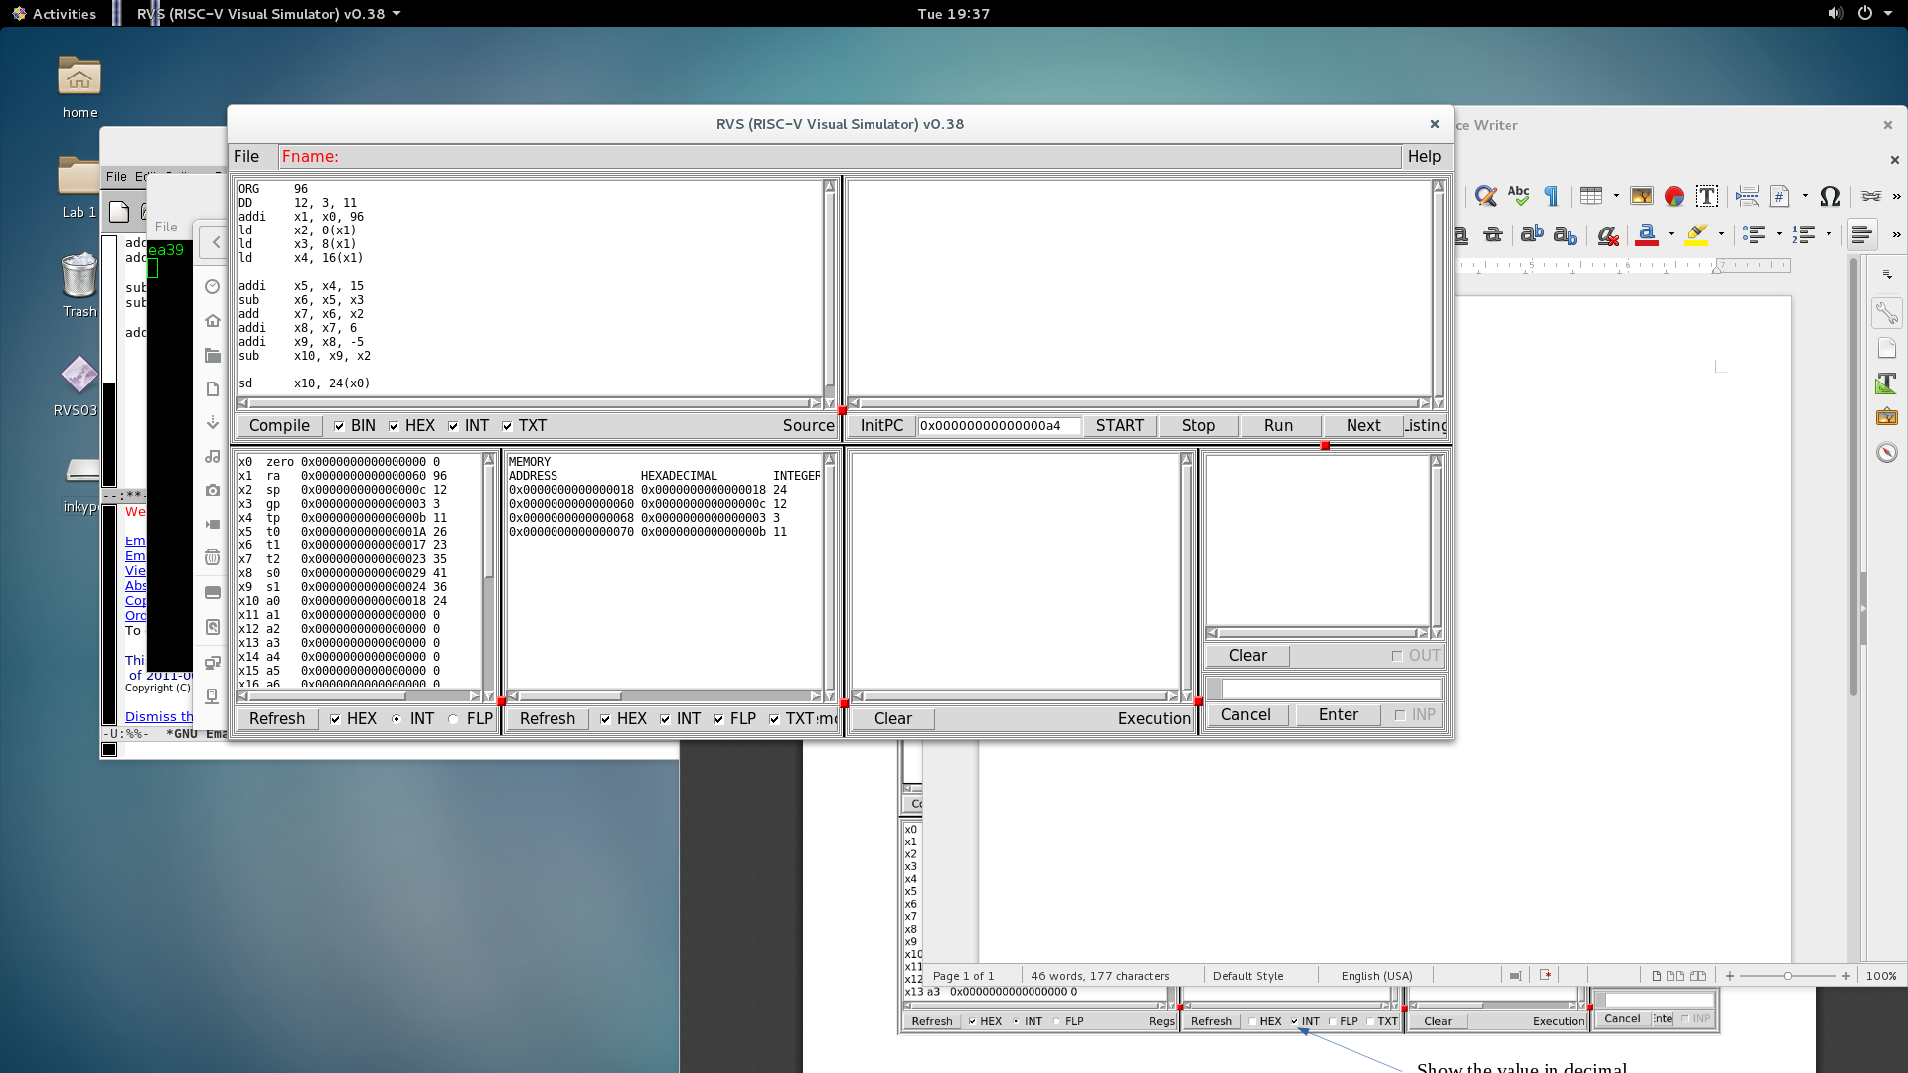

After Compiling:

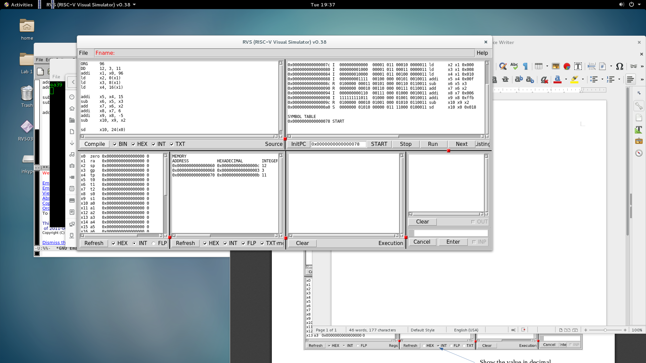

After running:

